Queering social perception: The effect of binary measurments on categorization and perception of binary gender ( provisional title)

**Overview & theoretical background**

Psychological research is coming to terms with something that has long been taken for granted in LGBTQ+ communities, namely that sex and gender are complicated multifaceted categories which cannot be summarised as a simple binary consisting of women and men. The consequences of this long-held misconception are only now being explored. We’ve seen how limited categories have restricted responses to surveys, and been bad for people answering questions about themselves. Relatively less work has looked at the consequences of restrictive categories for the categorization of others. Here, I propose a study to do just that, from a queer perspective.

Queer theory is an approach that is informed by the experiences of LGBTQ+ people, specifically the difficulty of fitting into rigidily defined categories of gender identity and sexuality. Queer theory is consequently characterized by a refusal to assume that those categories are natural and essential (Ellis, Riggs & Peel, 2019). From a queer perspective, it becomes clear that the dominant view of gender and sexuality consists of a network of ideas structured around binarity or duality of the two categories: women and men. Around this core idea follows a framework of other thoughts: women and men are different, women and men look different. In contrast to this, a core queer idea about gender is that it is perforrmative, in other words that gender is defined by continuous acts, not by essential properties (Butler, 1999). Alhtough some argue that queer theory is incompatible with the quantitative approach common in psychology, multiple people have shown that queer can add a lot to psychology, by shining a light on assumptions stemming from the heterosexual matrix (see Hyde et al., 2018; Hegarty & Thorne, 2014; Morgenroth & Ryan, 2018). Armed with queer theory, let’s examine the literature on gender perception and social categorization.

**Something something social categorization**

Social categorization is the process through which humans sort others according to membership in social groups (see Freeman & Anbady, 2011; Fiske & Taylor, 2013). Categorical thinking, as applied to humans, is a mode of thinking where individuals are primarily appraised according to the social group they belong to, rather than any individual qualities they may be possessed (Macrae & Bodenhausen, 2000). Although the idea has some support from neurological studies, in the main, categorical thinking has primarily been investigated as an outcome, and which ideas and categorizing evokes. For example, what characteristics are evoked by a masculine face or a masculine name. Many of the core ideas of social categories are highly compatible with queer theory, especially eg social identity theory, shifting identities etc. However, as we shall see, when looking at the categories evoked by faces, that is where we start having a problem.

For gender categorization, the problem comes from a very basic and common method in psychology. A very basic and commonly used method is to present participants with a face and ask them to pick one of several specified social categories. For gender, this is almost exclusively the categories woman and man (or “male” and “female”) (see for example, Cloutier et al., 2005; Campanella et al., 2001; Webster et al., 2004; Zhao & Bentin, 2008). Furthermore participants categorize gender in faces even when gender was task-irrelevant and when not instructed to do so (Mason, Cloutier, Macrae) and when presented with images degraded to the point that no individual qualities could be discerened (Cloutier, Mason & Macrae, 2005). Face composites of woman-man pairs are rated according to the gender category of the most prominent more often than might be expected purely on the basis of the physical features of the face. For example, a face composite of 70% woman and 30% man was categorized as a woman 90% of the time (Campanella et al., 2001; Freeman et al., 2010). The conclusions one might draw from these studies is that gendered perception is automatic, easy and organized according to the woman/man binary.

This research is important and beneficial, but it is important to note that the basic categorization paradigm at the heart of this literature carries with it a number of unarticulated ideas and assumptions about the nature of categories, which furthermore, are communicated to the subjects. One is that gender categories are distinct entities. One is that they are visible from faces. One is that it is binary. This issue is fundamental to the categorization paradigm. It can be partially alleviated by including the addition of additional categories or the option to refrain categorizing. When participants are given these options, many opt into them, suggesting that the standard categorization paradigm is unnecessarily restrictive (van Berlekom et al., in preperation). However, even with additional and queer categories, the basic categorization paradigm still has many of the problems just described. The inclusion of queer categories addtionally comes with the somewhat uncomfortable implication that queerness looks or should look a certain way. If we bring it back to queer and gender performative, binary categorization options is an example of how researchers force participant into a binary way of thinking. Forcing them to perform gender in a binary way.

So, how can we measure categorization in a way that truly allows participants to categorize queerly. The answer is pronouns. Pronouns are a curious little feature of language. In English the pronouns she and he do not directly constitute a categorization, but they are so strongly linked to genders that they can be taken for granted to have been used as the result of categorization according to their associated gender. Certainly, that is the experience of transgender and gender non-conforming people when referred to using the wrong pronoun (Uh… ref). In contrast, we have the gender-neutral pronoun they. Because it contains so many possibilities and does not restrict, it is queer! Uh, there are better ways to phrase that of course.

This section needs one final paragraph to bring the point home. Bring it in to a more concrete level about response options and so on. Basically, something to connect to the method described below.

**Overview of the present resesrch**

The overarching goal of the study proposed here is to investigate whether perceptions of gender measured with response options that reinforce binary gender norms leads participants to view gender as dimorrphic and to categorize gender as binary or queerly.

Social categorization will be tested using a slightly modified version of the classic categorization paradigm. Participants are presented with a face and then asked which pronoun they would use to refer to them. In the *multiple* *options* condition, participants choose from three possible pronouns: They, she or he. In the *free text* condition, participants are given a text box where they can write any pronoun the like.

Hypothesis: Participants categorizing according to multiple response options use “they” for more faces than participants responding with a free text.

Dimorphic perception will be tested using a judgement task with two conditions. Participants are shown a number of faces and asked to rate them in terms of genderedness. In the *single-scale* condition, participant rate the faces according a single scale with femininity on one end and masculinity on the other end. In the *multiple-scale* condition participants rate the faces for femininity and masculinity seperately. Participants rate several faces, perfect 50/50 morphs, 70/30 morphs and possibly just faces 100/0.

Hypothesis: The difference between 50/50 morphs and the other two types of faces will be larger in the *multiple-scale* condition than in the single-scale condition.

**Snips**

I suggest a modification of Campanella et al’s categorization study with the important independent variable being be measurment type. Either binary woman/man or multiple options, including “I don’t know” and non-binary, although there could be room for others as well. Campanella et al. Found perception to be categorical, which meant that faces were classified as women more often than the percentage of dimorphic “femininity” would suggest. This is illustrated using the red lines in figure 1. If binary measurment is causing participants to exaggerate perceived gender differences, we might expect the pattern of result to be similar to the blue line in figure 1. In other words, a 70% man morph would be categorized as “woman” 100% of the time.

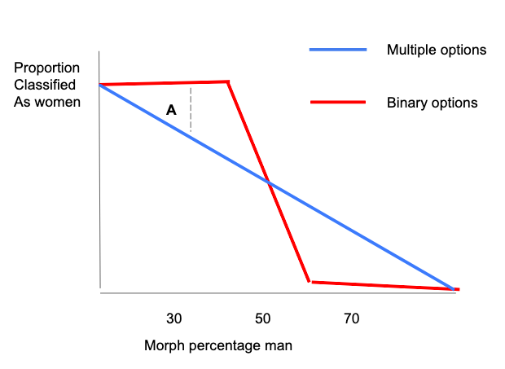

Figure 1. Hypothetical pattern of results from a categorization study comparing binary response options to multiple options. Dotted lines **A** epresent my suggestion for the main difference between the two conditions.

**Analyses & comparisons**

This presents a potentially difficult testing situation. There are a potential number of degrees of freedom. Which type of categorization should be compared? Which faces faces? I suggest a number of simplifications. First, I suggest limiting the analyses to one categorization, for example “women” categorizations.

Second, I see at least two ways to test the effect. One is illustrated by the dotted line **A** in Figure 1, simply comparing the number of 70/30 faces categorized as women when participants use binary or multiple response options. In this case, the relevant comparison would be of 70/30 faces only and other morph values may be included as within-subjects factors, but would only tested as negative controls because I would not expect there to an effect of response option at 50/50 faces or 100/0 faces. This would be quite simple. However, a possible concern is that the two conditions are so different that a direct comparison does not make sense.

Another option is illustrated in Figure 2 and would attempt to produce a measure which is more directly comparable. This option would require at least two morph types 70/30 and 50/50 as a within-subjects factor. The dotted lines B and C in figure 2 represent the average difference between 70/30 faces and 50/50 faces for participants responding using binary options (B) and multiple options (C). The relevant comparison would then be between the lines B and C. Comparing the difference scores would add a layer of complexity to the study. On the other hand, difference scores are arguably more comparable than the raw scores.

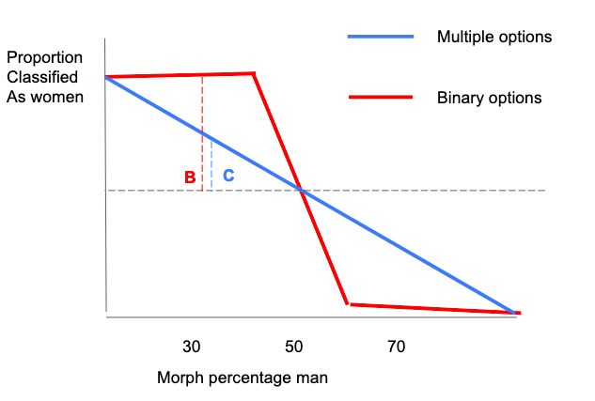

Figure 1. Hypothetical pattern of results from a categorization study comparing binary response options to multiple options. The Dotted lines **B** and **C r**epresent the hypothesized difference between 50/50 faces and 30/70 faces in each condition. The lines are meant to represent the same point on the X axis, but are kept slightly apart for illustrative purposes only.

**An alternative way to go**

I had another thought for a slightly different way to go as well. This idea is not clearly developed, but I’ll sketch it out very briefly. Basically, the thought is to investigate how measurement type (binary/multiple) affects which pronouns people use to describe a face. Here I’m imagining first you complete a categorization task similar to what we had in Study 1 and then people are either asked to describe the face or asked outright which pronoun they would use to describe that face. This gets at some conversations we’ve had earlier, pronouns are not labels, but they are indicative of categorization. In previous versions of the manuscript, we’ve talked about how misgendering is the real problem, not necessarily miscateorization, and what would be be best for most people would be if everyone avoided categorizing others, specifically verbally. Basically, someone can make an automatic categorization of someone else as “woman” but then have the second thought that gender is not visible from the face and use gender-neutral pronouns. I’m not sure if this is the best idea for the current study, but this sort of task could be a good continuation of study 1 in any case, with a measure that is closer to the relevant real-world behavior that we are interested in.

**Snips**

However, many of queer theories are compatible with psychology, and often the results show that the ways people categorize others are “queer” (Thorne & Hegarty, 2019).

Something about how experimenters bring their own assumptions about gender into studies. How

do psychologists talk about and treat gender categoreis? Well, very clearly as a binary, but also as a “natural” “essential” category. An important caveat to this research is that the binary nature of gender is almost invariably taken for granted in this research. Furthermore, gender is assumed by researchers to be an important organizing principle. For example,

Another challenge to this perspective is to point to the lived experiences of LGBTQ+ people. The existence of people who are Transgender and Gender Non-conforming (TGNC) suggests that the binary only studies are overly simplistic. Importantly, the queer experience is not defined by additional identities that function in a similar way to woman and man, but a multiplicity of flexible and fluid categories which may or may not be mutually exclusive to each other.

Much of the early work in this field evoked categories in a fairly simplistic way, by just writing out the category. This allowed that literature to examine ideas connected to social categories. Lately, we’ve started looking at faces too. The thing with faces is, they’re less digital, which more generally raises the question of what kind of categories are made. Furthermore, a face can be identified as belonging to a woman or a man, or it can be viewed as more or less feminine.

A big topic within this field is the degree to which gender categories are applied automatically. categorization. For gender specifically, there is some evidence from this body of work that categories are automatically activated. Researches in this tradition have identified gender as a particularly prominent characteristic and category, to the extent that people effortlessly judge gender from faces and automatically categorize others according to gender. Electroencephalographic (EEG) research has shown differential neural responses to feminine and masculine faces at 170 ms, leading to the common conclusion that people categorize gender within milliseconds of seeing a face (Freeman & Johnson, 2016; Kloth et al., 2010). Evidence for the automaticity of gender categorization comes from work showing that humans categorize gender even when not instructed to do so, (refs).

From this perspective, it also becomes quite clear that the literature of perception and categorization of gender makes a lot of assumptions based in the heterosexual matrix. Within this matrix is the idea that women and men are two distinct categories of people, with equally distinct appearances, and distinct facial features. In this system, faces are dimorphic and facial gender is defined as a single dimension with femininity on one end and masculinity at the other. According to this system, maleness, masculinity, and masculine facial features are all equally linked and femaleness, femininity, and feminine facial features are the opposite. The language used in studies supports this casual conflation of concepts.

I have a lot of underdeveloped ideas about measurment in general. I’m not even sure it will make it’s way into the final paper, but my thinking here is influenced by queer theory and feminist criticisms of science such as Haraway and Harding. One of the central ideas of queer theory is a rejection of the idea of categories. From a queer perspective, it becomes clear that the existence and importance of categories is routinely taken for granted by social psychology. Asking participants to categorize a face on the basis of two gender categories singled out by the researchers, from this perspective, constitutes not just a neutral measurement of a naturally occurring phenomenon, but a creation of a new situation where the researcher and subject work together to build a shared understanding of reality. The results from such studies are not necessarily invalid, but the queer perspective does show the literature has not considered the impact of measurement on the outcomes.

What does that mean for psychology? Well,this leads to the conclusion that how gender is measured can shape the results that we get. Therefore, we want to compare three types of measures of gender categorizations.

**Something something dimorphic perception of gender**

A related topic is the study of the dimorphic nature of faces and face perception. Gender as a facial characteristic is described as dimorphic, meaning as a single dimension defined as femininity on one end and masculinity on the other end. A related issue is whether are perceived dimoprhically. These are of course two different questions, but they go hand in hand Are faces dimorphic and are they perceived as dimorphic. Well, let’s see what the literature has to say.

The literature on face perception is a little bit complicated, but there are basically two approaches one can take when investigating the relationship between faces and perceived characteristics. The first is perhaps broadly defined as exploratory. Quantifying the shape of faces (using a field of research called morphometrics) and applying dimension reduction on that data. With this method, researchers have found one or two broad dimensions, which have alternatively been refereed to as approach and dominance (Todorov et al.,2008) and babyfacedness (Zebrowitz, 2007). The second approach is to investigate predefined dimensions, based on the average faces of existing groups of people, such as self-identified women and men. Researchers using this approach have reported that scores on this dimension are correlated with ratings of masculinity and femininity (Komori et al., 2011; Mitteroecker et al., 2015; Zaidi et al., 2019).

Here a paragraph outlining the results of Huart et al., 2015 and Wittlin et al., 2018. The point I want to make is similar to the paragraph in study 1 outline those papers, which is that people’s perceptions of gender can change depending on external stimuli. In other words, it is *queer* in the sense of not being stable.

Hester et al demonstrated very clearly that masculinity and femininity are not a singular dimension. Analysing data from ratings of faces of two databases, they showed convincingly that many of the assumptions of the binary viewpoint were not supported by empirical tests. These included the assumptions that both dimorphic facial features reflect and perceived femininity and masculinity reflect a single latent variable. This fits in with Hyde, 2019 about how research tends to focus on gender differences, obscuring similarities. Hester shows that people don’t necessarily view gender as dimorphic when asked in a way that let’s them express not that.

The conclusion I want to reach from the combination of the last two paragraphs it that perception of gender is not necessarily dimorphic, but it could become more dimorphic if the researchers communicate binary and dimorphic ideas of gender to the participants. Measuring perceived gender using a one-dimensional scale does suggest that femininity and masculinity are opposite. Therefore, measuring perceived gender as singe one-dimensional scale may make participants more prone to viewing gender as dimorphic.